Lab Assignment 5 Design and Analysis of Algorithms

Name: Tanvi Penumudy

Enroll No: E18CSE187

Ques 1 Screenshots:

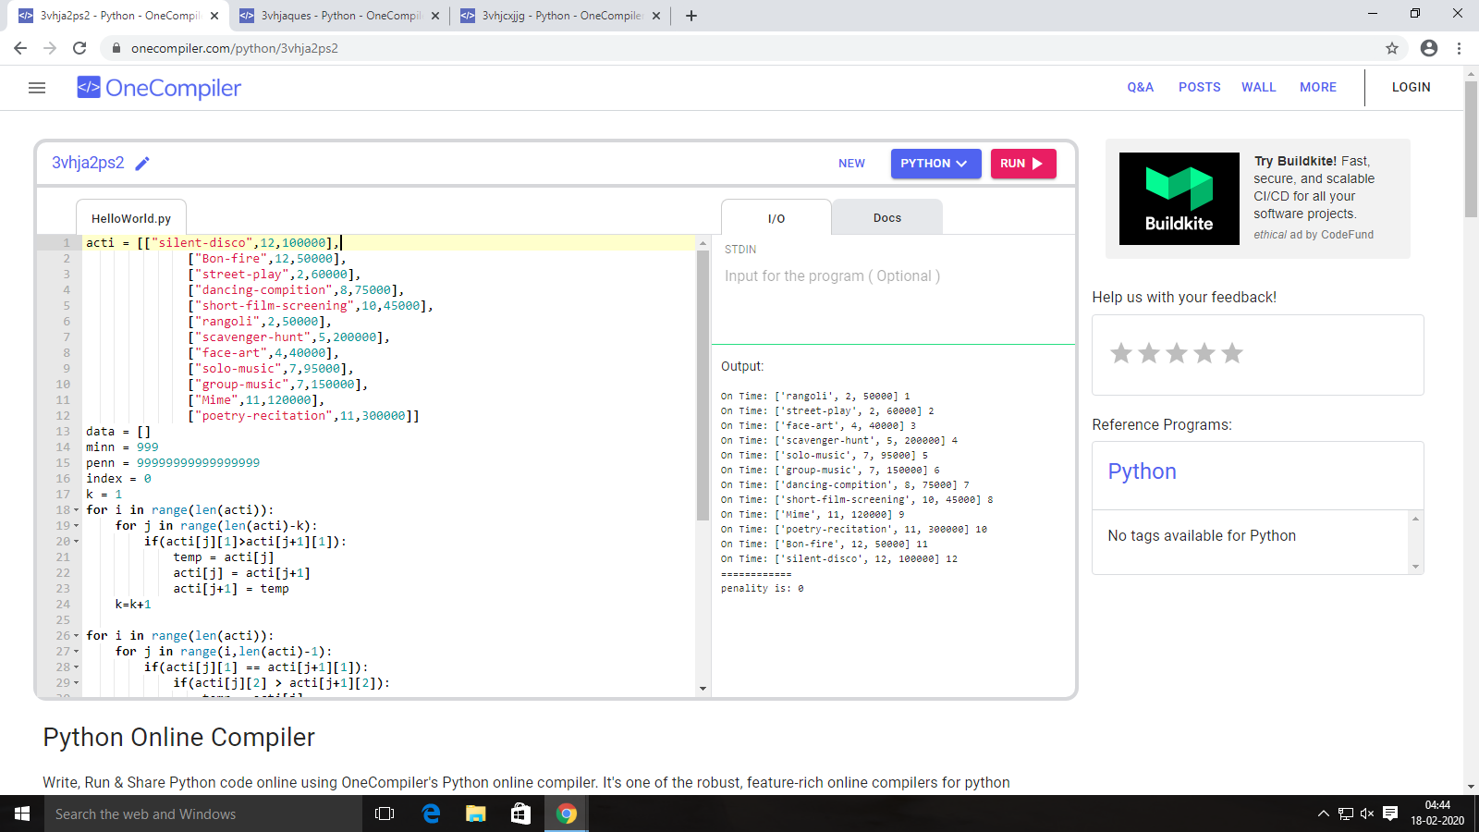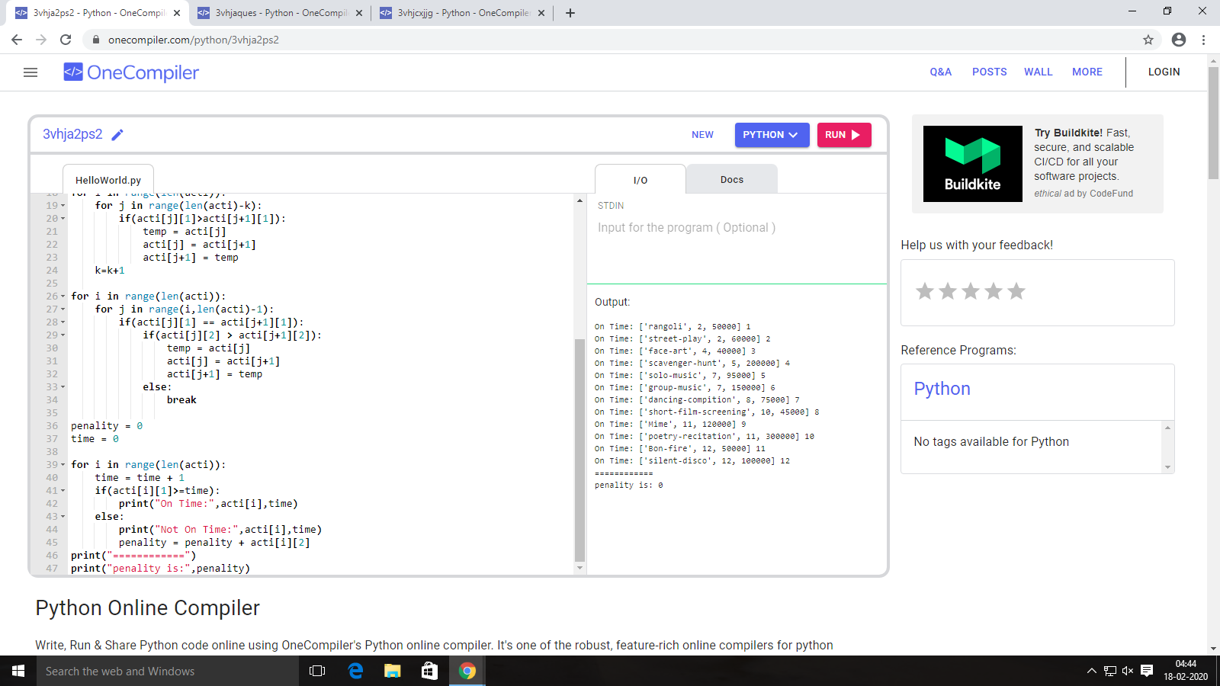

Output:



Ques 2 Screenshots:

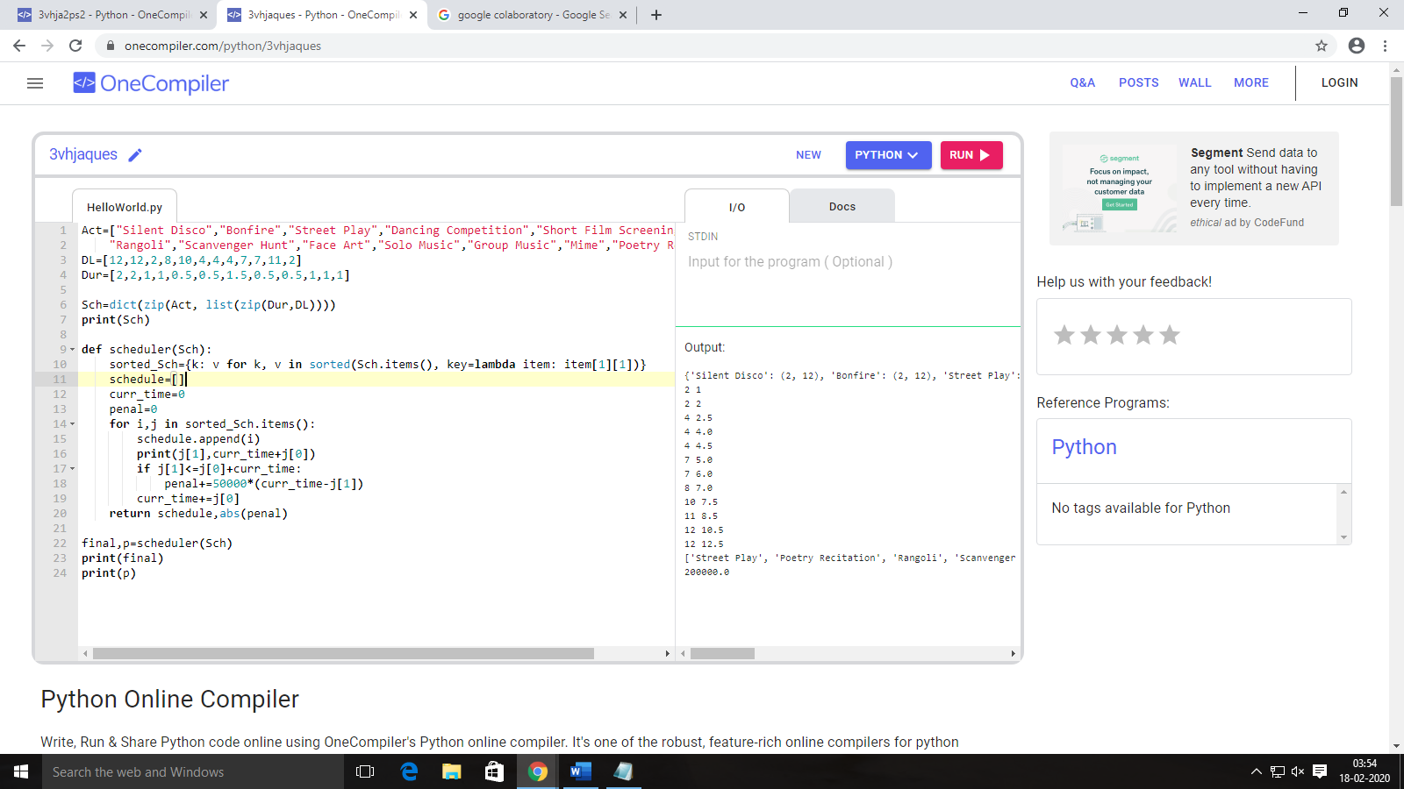

Output:

